**Exercise 0.1 – Explore the interactive workspace**

Work through the following exercises to give you a short taster of some of the MATLAB commands and to get you used to the interactive workspace. This exercise will help you when you come to do the examples on which this course is assessed.

Start with some basic commands.

1. MATLAB can do arithmetic like a standard calculator. Notice the precedence of the operators. In the Command Window do the following:
2. 5+12
3. 5*12
4. 5*sin(30*pi/180 )
5. 3^2 – 6*3

Notice that the result is assigned to the variable name ans.

Look in the Workspace. Right-clicking on the column headings allows you to select which properties of the variable you want displayed.

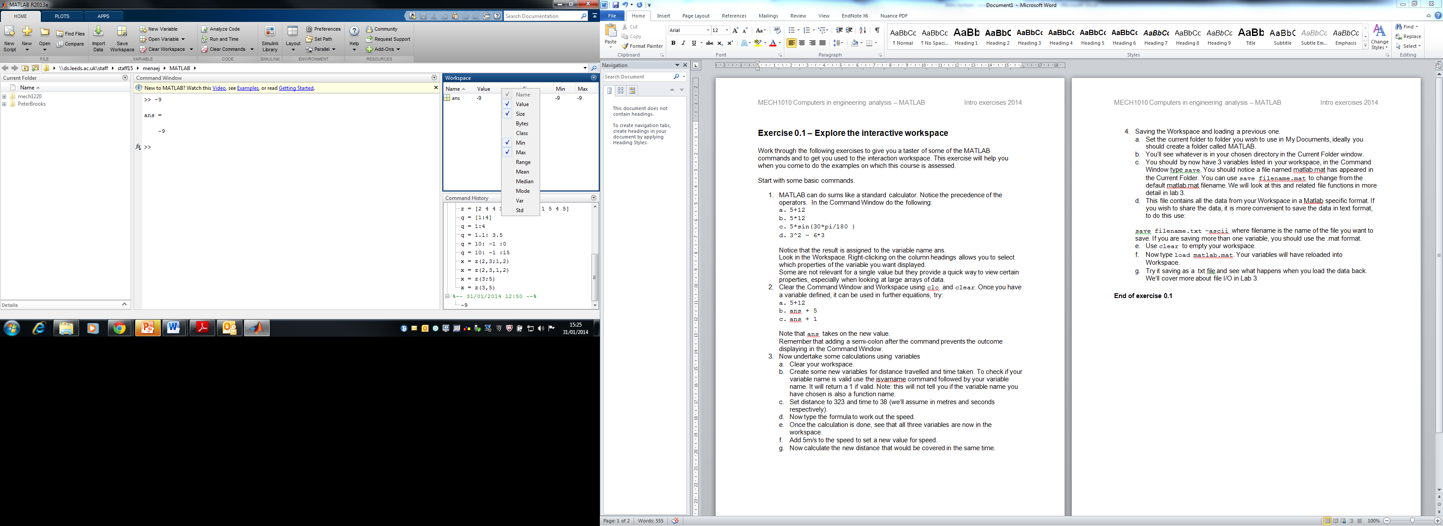

Some are not relevant for a single value but they provide a quick way to view certain properties, especially when looking at large arrays of data.

1. Clear the Command Window and Workspace using clc and clear. Once you have a variable defined, it can be used in further equations, try:
2. 5+12
3. ans + 5
4. ans + 1

Note that ans takes on the new value.

Remember that adding a semi-colon after the command prevents the outcome displaying in the Command Window.

1. Now undertake some calculations using variables
2. Clear your workspace.
3. Create some new variables for distance travelled and time taken. To check if your variable name is valid use the isvarname command followed by your variable name. It will return a 1 if valid. Note: this will not tell you if the variable name you have chosen is also a function name. Use which *variable_name* to check if your variable name is used, if it returns a file path, then a function or variable already exists. For example, you may find *distance* is already a function name however *distance_travelled* is not.
4. Set distance_travelled to 323 and time to 38 (we’ll assume in metres and seconds respectively).
5. Now type the formula to work out the speed.
6. Once the calculation is done, see that all three variables are now in the workspace.
7. Add 5m/s to the speed to set a new value for speed.
8. Now calculate the new distance that would be covered in the same time.
9. Saving the Workspace and loading a previous one.
10. Set the current folder to folder you wish to use in My Documents, ideally you should create a folder called MATLAB.
11. You’ll see whatever is in your chosen directory in the Current Folder window.
12. You should by now have 3 variables listed in your workspace, in the Command Window type save. You should notice a file named matlab.mat has appeared in the Current Folder. You can use save filename.mat to change from the default matlab.mat filename. We will look at this and related file functions in more detail in lab 4.
13. This file contains all the data from your Workspace in a MATLAB specific format. If you wish to share the data, it is more convenient to save the data in text format, to do this use:

save filename.txt –ascii

where filename is the name of the file you want to save. If you are saving more than one variable, you should use the .mat format.

1. Use clear to empty your workspace, note your variables will now have disappeared.
2. Now type load filename.mat. Your variables will have reloaded into Workspace.
3. Try it saving as a .txt file and see what happens when you load the data back using load filename.txt –ascii

We’ll cover more about file I/O in Lab 4.

**End of exercise 0.1**